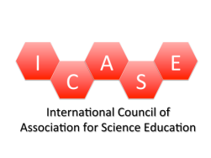
Science Education International
Vol. 24, Issue 1, 2013, 78-97
A comparative analysis of PISA scientific literacy framework in Finnish and Thai science curricula
Pavinee Sothayapetch, Jari Lavonen, Kalle Juuti
ABSTRACT: A curriculum is a master plan that regulates teaching and learning. This paper compares Finnish and Thai primary school level science curricula to the PISA 2006 Scientific Literacy Framework. Curriculum comparison was made following the procedure of deductive content analysis. In the analysis, there were four main categories adopted from PISA framework: (1) knowledge of science (content knowledge), (2) knowledge about science, (3) competences, and (4) contexts. The analysis revealed that the Thai curriculum was more similar to the PISA framework than was the Finnish curriculum. The Thai curriculum emphasizes the scientific process and the Finnish curriculum the concepts and contexts in which these concepts meet, rather than the process.
KEY WORDS: national level curriculum, science curriculum, primary school, content analysis, Thai science education, Finnish science education

Introduction
A curriculum is a document that guides the education processes on a national or local level (Kelly, 2009; van den Akker, 2003). In some countries, such as the UK, there is a centralised education system and, in other countries, such as Finland and Thailand, a decentralised education system where a local curriculum is prepared, based on the national level curriculum. However, in both cases the national level curriculum is an important tool for the implementation of the national education policy. A curriculum is a tool for renewal of science education. For example, Science Education International introduces several renewal programs where the role of the curriculum is important, such as a renewal of inquiry-based (Chabalengula & Mumba, 2012) or context-based (Valdmann, Holbrook, & Rannikmäe, 2012) science education.
Curriculum theorists argue that two types of curricula are guiding teaching and learning at school. The intended, official, virtual, overt, or explicit curriculum is a ‘formal’ document that describes ‘official’ aims and contents or describes an intentional instructional agenda of a school. The hidden, implicit, or covert curriculum is made up of the unwritten ‘messages’ that students receive from their school environment, informal codes of conduct, behaviours, and attitudes that are learned through interactions with teachers, administrators and others in schools (Oliva, 1997).
Our aim is to compare intended national level curricula in two different countries in order to compare intentional instructional agendas. We will present the comparison of a high- and a low-performing country in the PISA Scientific Literacy Assessment in order to see if there are differences in the aims the intended curriculum is emphasising in two differently performing countries. We choose the Finnish and Thai national level intended primary science curriculum for the analysis. Finnish PISA scores have been extraordinary, because of both the high scores and the low variation of performance (OECD, 2007; 2010). On the other hand, the PISA results of Thai students are among the lowest. The similarities between the Finnish curriculum and PISA science framework have been one proposed explanation for Finnish students’ success in PISA (Lavonen & Laaksonen, 2009).
Even though curriculum analysis will not offer information on the classroom practice level or hidden curriculum, it will clarify the guidelines that the teachers should follow and take into consideration in their teaching. Teachers need to know the curriculum guidelines while they decide on teaching methods, select content and learning materials, and decide on ways to assess students’ achievement.
This study analyses similarities and differences between the national level curricula in Finland and in Thailand in order to determine the core aims and contents. However, the research on science curriculum it is not straightforward because the education context and the terminology used in the curriculum documents vary between countries and researchers. For example, the use and definitions of the terms objective, aim, goal, ability, learning outcome, and competence vary. ‘Goals’ is used typically to describe the overall purpose of a subject or a course in a national level curriculum. ‘Aims’ break down goals into measurable behaviours. Objectives are stated in narrower, precise, concrete and measurable terms. They are stated in terms of what the learner should know or be able to do or have attained by the end of a course or compulsory school; these attainments are called learning outcomes (Duggan & Gott, 1995).
We will apply the PISA 2006 Scientific Literacy Framework (OECD, 2006) as a framework for the analysis. There were two reasons why we chose this framework. Firstly, the Finnish and Thai primary science curricula differ a lot and the PISA frame offers a neutral frame for the analysis. Secondly, our aim is to compare national-level curricula to an internationally agreed framework that is used to assess how well students have acquired the knowledge, skills, and scientific literacy that are essential for their full participation in society or competence for all lifelong learning. These aims are fundamental national level aims for education. In what follows next, we introduce Finnish and Thai primary science education.

Science Education in Finland
Finnish national policy emphasises broad literacy and, consequently, all school subjects have equal priority in Finnish curriculum (Lavonen, 2008; Ståhl, 2012). The Finnish National Core Curriculum for Basic Education (FNBE, 1994; FNBE, 2004) describes the national aims and contents for physics, chemistry, and biology education. In addition to conceptual knowledge, “science curriculum emphasises activities in which the students can identify, recognise or observe scientific issues, explain or interpret data or scientific phenomena, and draw conclusions based on the evidence” (Lavonen & Laaksonen, 2009, p. 924). Practical work and demonstrations, aiming at learning process skills, have long been accepted as an integral part of teaching and learning of science subjects (Asunta, 1997).
Science covers six subjects: environmental and natural studies, biology, geography, physics, chemistry, and health education in grades 5–9. In grades 1–4, there is an integrated subject of environmental and natural studies. There are altogether 38 weeks in a school year and each lesson lasts 45-minutes. The average number of science instruction lessons per year on each level is as follows: grades 1–4, 64 lessons per year; grades 5–6, 71 lessons per year; thus a total of 400 lessons are allocated for science studies on grades 1–6 in Finnish compulsory school.
According to the Finnish core curriculum, the purpose of science teaching in general is to help students to: (1) perceive the nature of science; (2) learn new scientific concepts, principles, and models; (3) develop skills in experimental work; (4) engage in cooperation, and (5) become stimulated to study physics and chemistry (interest) (NCCBE, 2004). Finnish aims are described as broad aims indicating what a teacher should teach at science lesson.
In grades 1-4, Environmental and natural studies is an integrated subject group comprising the fields of biology, chemistry, geography, physics, and health education. This is a compulsory subject. The aim of the instruction is to teach students to know and understand nature and the built environment, themselves and other people, human diversity, and health and disease. There are four content areas in environmental and natural studies: physics, chemistry, biology, and organisms and living environments. The latter covers issues on the basic features of living and non-living nature and the adaption of organisms. The source and production of food is also covered.
In grades 5–6, there are two science subjects: integrated biology and geography, and integrated physics and chemistry. Important topics of physics are, for example, energy and electricity, scales and structures; and important topics of chemistry are substances in the environment, the atmosphere, water, classification of substances, and recycling of products. Energy and electricity is an important area of physics. According to the core curriculum, the students should learn about the production of heat, light, and motion with the aid of electricity; safety with electricity and various ways of producing electricity; and energy resources. Students should learn science process skills in physics and chemistry, such as:

• formulation of questions
• making of observations and measurements
• presenting and testing of hypothesis
• processing, classifying, presenting and interpreting observations and data
• making of evidence-based conclusions
• formulating simple models and using of these models for explaining phenomena
• looking for information from different sources of information;
• carrying out simple scientific experiments.

Science Education in Thailand
Chandavimol (1990) described the Thai curriculum after reform in the end of the 1980s. In that reform, the process approach was emphasised. According to Yuenyong and Narjaikaew (2009), the next reform in 1999 focused on scientific literacy: “Thai science education emphasizes the scientific knowledge, the nature of science, and the relationship between science technology and society” (p. 335). The definition of scientific literacy in the Thai science education context focuses on citizens who are to be able to: (1) perceive questions and problems that could be verified through the scientific method, (2) identify evidence or data for inquiry, (3) give reasonable explanations related to empirical data or evidence, (4) communicate or explain issues related to science, and (5) understand scientific principles and concepts. The Institute for the Promotion of Teaching Science and Technology (IPST) (2002) emphasised that, although Thailand is not a member of the OECD, the country aims at a similar scientific literacy to that of OECD member states.
Science is a compulsory topic for Thai students in every grade from the primary level to the upper-secondary level. The time allocated to science instruction is 80 lessons per year at all primary levels. The duration of a lesson is 50 minutes. Altogether, there are 480 lessons allocated in grades 1–6 in Thai schools. There are eight content areas in the curriculum: (1) living things and processes of life, (2) life and the environment, (3) substances and properties of substances, (4) forces and motion, (5) energy, (6) change process of the earth, (7) astronomy and space, and (8) nature of science and technology (Ministry of Education, 2008).
Each content area or topic contains sub-topics and, under the sub-topics, there are standards of science as well. Students in different grades are taught the same main content and sub-topics but at the appropriate grade level. The standards of science dictate what subject matter the students should learn under each content area or sub-topic. Consequently, the aims are described in the form of learning outcomes. The descriptions of specified grade level learning outcomes could be interpreted as guidelines for teachers’ instruction so that learners will learn indicated topics. For example, general standard for the topic of Living organism and family is: ‘Understanding basic units of living things; relationship between structures and functions of living things, which are interlinked; investigative process for seeking knowledge; ability to communicate acquired knowledge that could be applied to one’s life and care for living things’ (Ministry of Education, 2008).
In general, the purpose of science teaching in Thailand is described as follows: Science teaching should help the students (1) understand basic principles and theories of science; (2) understand the limitations and nature of science; (3) gain skills of investigation, scientific and technological formulation; (4) develop the process of thinking and imagination, and the ability of problem solution and management, communication skill, and ability for decision; (5) recognize the relation among science, technologies, human beings, and environments in terms of influence and affectation; (6) apply the knowledge of science and technology for making the usefulness to society and living; and (7) have a scientific mind, ethics, and value in the use of science and technology originally. Like Finnish science education, Thai science curriculum also recognises how to make the students attain these teaching purposes in their science learning. For this reason, Thai science teachers in every grade level have a main responsibility for this important task (Ministry of Education, 2008).

Methods

Analysis Framework of Science Curricula at Primary Level
The aims for science education in the Finnish and Thai science curricula are presented in different ways: Finnish aims are presented in the form of broad aims for teacher teaching and Thai aims are descriptions of learning outcomes. In order to have an independent and general view in the content analysis of the primary science curriculum, the PISA 2006 Scientific Literacy Framework (OECD, 2006) or, in its short form the ‘PISA science framework’, was used as an analytical frame for the analysis.
The 2006 PISA science framework (OECD, 2006) defines three competency fields that describe the use of content knowledge of science and knowledge about science and willingness to use this knowledge (attitude) in three situations: in identifying scientific issues, in explaining scientific phenomena, and in drawing evidence-based conclusions. The description of each competency is shown in Figure 1.

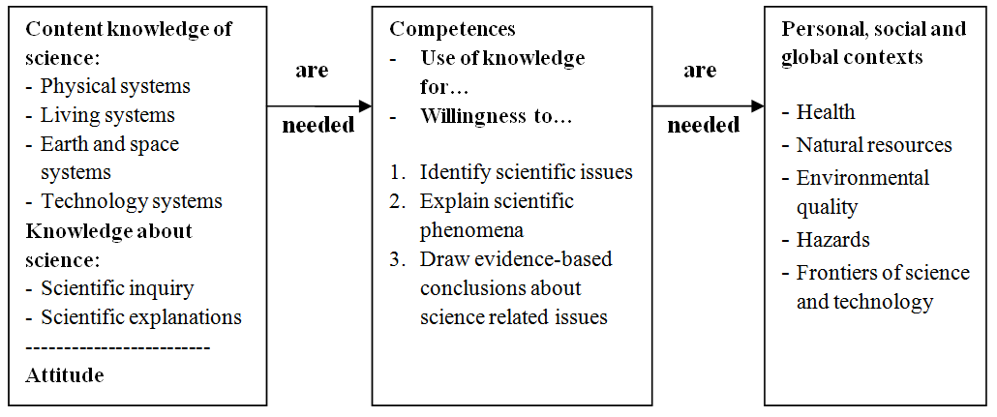
Figure 1. Aspects of PISA Scientific Literacy Framework

Three main aspects (competence, contents, contexts) are emphasized in the PISA 2006 science framework (OECD, 2006). This framework is used for science test and item design, There are components under each aspect; for example, the competence aspect, the first main category, emphasises the content knowledge classified into two sub-categories: knowledge of science and knowledge about science. The first sub-sub-category in the ‘knowledge of science’ includes both physics and chemistry knowledge.
The second main category is defined in terms of an individual’s scientific knowledge and use of that knowledge to identify scientific issues; explain scientific phenomena and draw evidence-based conclusions. We included in the first sub-category, ‘identify scientific issues’, planning and implementation of science inquiry; therefore, practical work in a science curriculum was assigned to this sub-category. The second sub-category, ‘explain scientific phenomena’, includes descriptions in a curriculum that refers to the use of knowledge, such as problem solving in science. The third sub-category, ‘draw evidence-based conclusions’, includes the use of different types of information available in texts, tables or experiments.
The last main category used in the content analysis focuses on the contexts. The PISA 2006 science questions were framed within a wide variety of life situations involving science and technology. Consequently, the contexts used for questions were chosen according to the relevance to students’ interests and lives, representing science-related situations that adults might encounter. The detail of all three aspects is shown in Figure 2.

- Content Knowledge
Knowledge of science | Knowledge about science
Physical systems: Structure of matter; Properties of matter; Chemical changes of matter; Motions and forces; Energy and its transformation; Interactions of energy and matter | Scientific inquiry: the central process of science and the various components of that process.
Living systems: Cells; Humans; Populations; Ecosystems; Biosphere | Scientific explanations: the results of scientific enquiry.
Earth and space systems: Structures of Earth systems; Energy in Earth systems; Change in Earth systems; Earth’s history Earth in space
Technology systems: Role of science-based technology; Relationships between science and technology; Concepts; Important principles
- Competences
Identify scientific issues includes planning of inquiry activities and collection of data. Identifying verbs such as observe, experiment, inquiry, investigate
Draw evidence-based conclusions includes the use of textual, pictorial or table information in drawing conclusions. Identifying verbs such as interpret, explain, discuss, make, formulate
Explain scientific phenomena include applying knowledge of science or knowledge about science in a given situation. Identifying verbs such as apply, use, describe, solve
- Contexts (personal, social, and global)
Health: maintenance of health, accidents, nutrition, epidemics, spread of infectious diseases
Natural resources: populations, quality of life, security, renewable and non-renewable energy sources, natural systems
Environmental quality: population distribution, disposal of waste, environmental impact, local weather, biodiversity, ecological sustainability, control of pollution
Hazards: rapid changes, climate change, impact of modern warfare
Figure 2. Three main aspects in the PISA Scientific Literacy Framework

Content Analysis of the Finnish and Thai Curricula
While analysing the curriculum text, we followed the Weber (1990) and Neuendorf (2002) example of content analysis. The analysis proceeded in the following steps:

- We identified the main categories and sub-categories and writing of the definitions for categories based on the PISA 2006 science framework. Therefore, the analysis can be characterised as deductive.
- We classified the textual information from both science curricula at primary level according to main categories and sub-categories. Altogether, there were 10 standard pages in the Finnish curriculum and 20 pages in the Thai curriculum. One sentence might include several ideas. Therefore, one sentence could belong to more than one category.
- We made tables based on our content analysis in order to calculate the frequency and percentage of each category defined by the PISA 2006 science framework.
- After the content analysis, we employed a non-parametric test for comparing the science curricula.

The classification process (step 2) started with recognising units in both curricula texts. We recognised that it was most appropriate to take one single idea as a unit of analysis; therefore, one sentence was typically divided into several units. However, in one unit typically at least one competence and one content area or a context was mentioned. We recognised this when two researchers were classifying 10% of each curriculum independently. The agreement was on average about 70%. After this trial, we wrote the descriptions of the categories more carefully and decided on following procedure:

- The first author, familiar with the Thai context, classified all units in both curricula according to main and sub-categories. Altogether, there were 553 units.
- The second author, familiar with the Finnish context, went through all classifications, using the track changes tool. The second researcher recommended altogether 135 changes.
- The first author reconsidered all the changes that were recommended by the second researcher.
- The second and third authors discussed the recommendations the first researcher did not accept until they decided the final classifications by consensus. Altogether, there were five single discussions.

Table 1. Outcome of the Content Analysis by the Second Researcher
Textual information | Knowledge of science: | Knowledge about science | Competence | Context
The learning area of science is aimed at enabling learners to learn this subject with emphasis on linking knowledge with processes, |  | nature of scientific inquiry | identify scientific issues
acquiring essential skills for investigation, building knowledge through investigative processes, |  | nature of scientific inquiry | identify scientific issues
seeking knowledge and solving various problems. [solving problems means use of knowledge] |  | nature of scientific explanations [new]  nature of scientific inquiry [deleted] | explain scientific phenomena [new]  identify scientific issues  [deleted]
Learners are allowed to participate in all stages of learning, with activities organized through diverse practical work suitable to their levels. |  |  | identify scientific issues
The main content areas are prescribed as follows: living things | living systems |  |  | natural resources
and processes of life: | living systems
basic units of living things; | living systems
biodiversity; | living systems |  |  | environmental quality
genetic transmission; | living systems |  |  | health
functioning of various systems of living things, evolution | living systems
and diversity of living things | living systems |  |  | natural resources
Therefore, the content analysis was iterative in nature. Table 1 presents an example of the content analysis outcome. The process of iterative nature of the analysis is shown by the crossed-out terms. Finally, the percentages of each category are calculated based on the content analysis of the study and demonstrated by 100% stacked bar charts.

Results
The results of the theory-driven content analysis, where the PISA 2006 Scientific Literacy Framework was used as a framework for the analysis, are presented next. The textual information for analysis amounted to 30 standard pages and 553 analysis units divided into 156 units in the Finnish science curriculum, and 397 units in the Thai science curriculum. The outcomes of deductive content analysis are described in Figures 3-7.

Knowledge of science
Figure 3 summarizes the knowledge of science in both curricula. The analyses revealed that the main emphasis was on physical and chemical and living systems in both countries. In the Finnish curriculum, the study of living systems was emphasized relatively in double percentages compared to the Thai curriculum. Examples of knowledge areas not related to any PISA category were aims/learning outcomes emphasizing social relations between human beings or aims emphasizing only science inquiry procedures. In Finland, geography is taught integrated with science. Therefore, the Finnish science curriculum introduced geography content such as Europe as a part of the world, map view of Europe, Europe's climatic zones, vegetation zones, and human activity; all these topics can be categorized in some aspects of the PISA science framework, but not all. Thus, there were some topics that are not science, like world map's main nomenclature and map skills, and consequently they were not taken as a part of the calculation in the analysis.

Knowledge about science
The Finnish and Thai percentage distributions in knowledge about science differ insignificantly (Figure 4). There were several aims that could not be classified to the categories related to the ‘Knowledge about Science’ category. The percentages show the same pattern of frequencies in both countries. However, both categories were under represented in the Finnish curriculum.

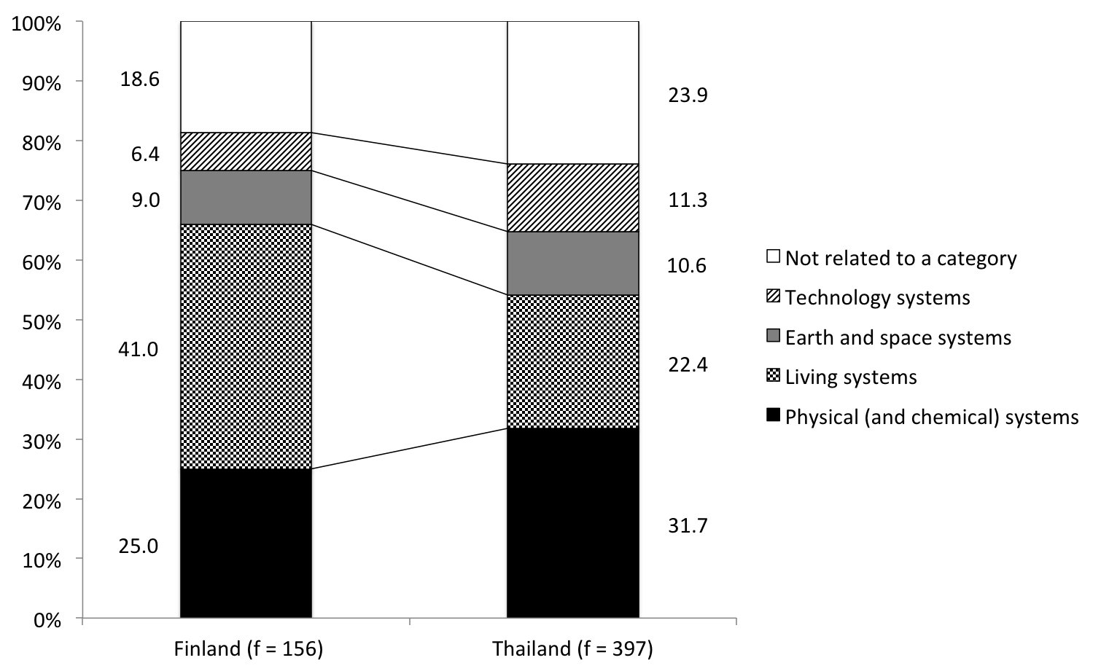
Figure 3. The comparative percentage of the sub-categories in knowledge of science category

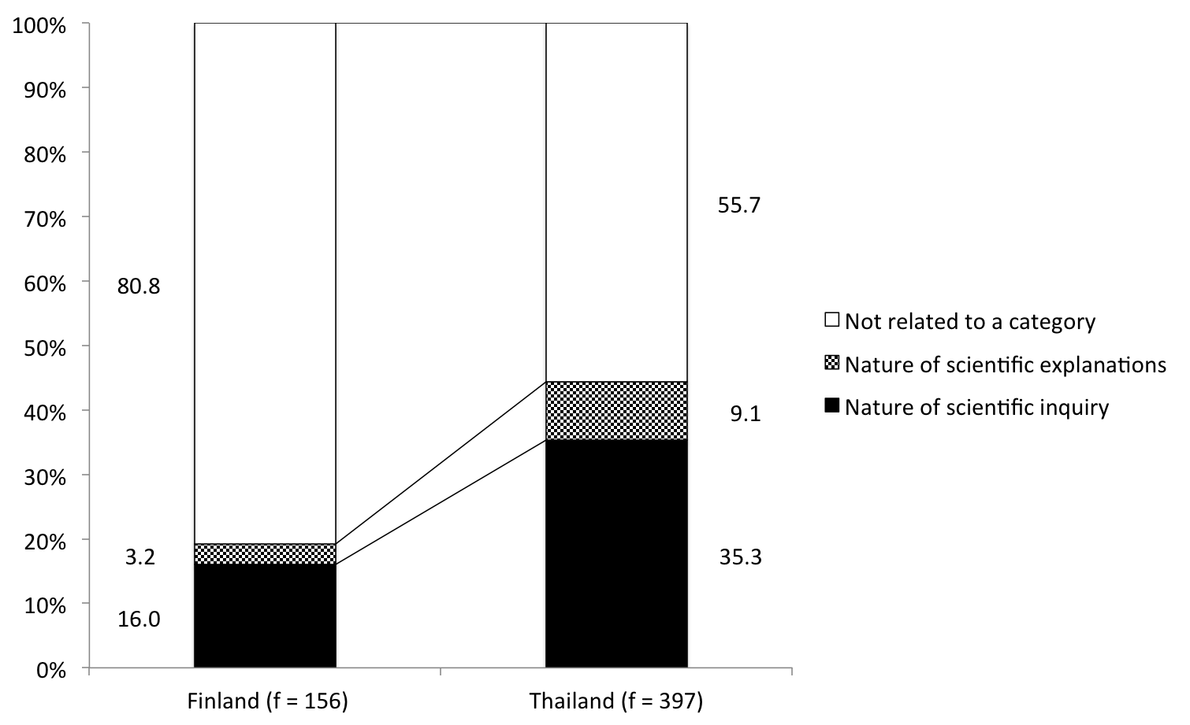
Figure 4. The comparative percentage of the sub-categories in knowledge about science category

Science competences
The percentages of PISA competence are shown in Figure 5. The Finnish and Thai percentage distributions differ significantly. ‘Identify scientific issues’ (f = 31.7%) and ‘draw evidence-based conclusions’ (f = 26.2%) were used mostly in the Thai science curriculum with the approximate percentages. In Finland, the percentages of ‘draw evidence-based conclusions’ was seldom seen as an aim compared to other competences (f = 5.8%). In general, in Finland, three PISA science competences were indicated among the aims much more seldom than in the Thai curriculum: in Finland altogether 57% of the aims were not focused on three PISA science competences.

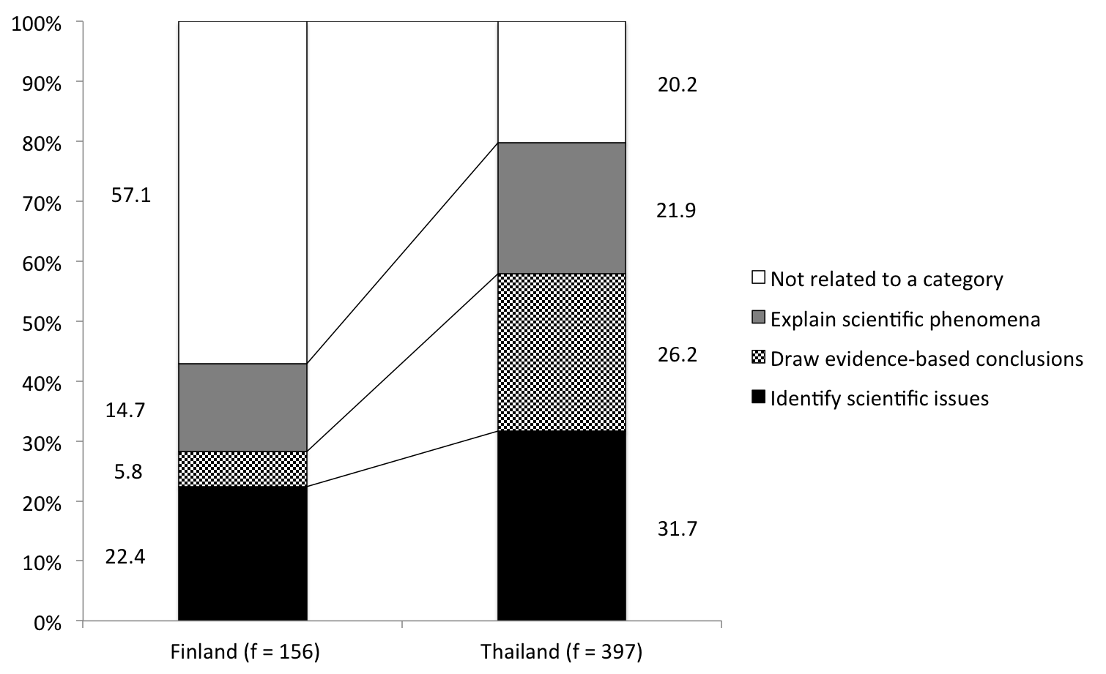
Figure 5. The comparative percentage of competence analysis in Finnish and Thai science curricula

Contexts
The frequencies of the contexts where the aims or contents were presented in the Finnish and Thai science curricula are shown in Figure 6. In the Finnish curriculum, there were more rich contexts (compared with the total number in the textual information analysis) indicated in the curriculum than in the Thai curriculum.
It is notable that the Finnish and Thai distribution differed significantly in Figure 6. The first three groups of contexts aligned closely with the percentages in the Finnish science curriculum. In Thailand, ‘Not related to a category’ had the highest percentages compared to other categories (f = 61.7%). In the Finnish curriculum, environmental quality and health contexts were presented much more frequently than in the Thai science curriculum. In the Thai curriculum, contexts of natural resources, frontiers of science and technology, and hazards were used more often than in the Finnish science curriculum. In Finnish curriculum, only one per cent content was classified in the category of frontiers of science and technology context.

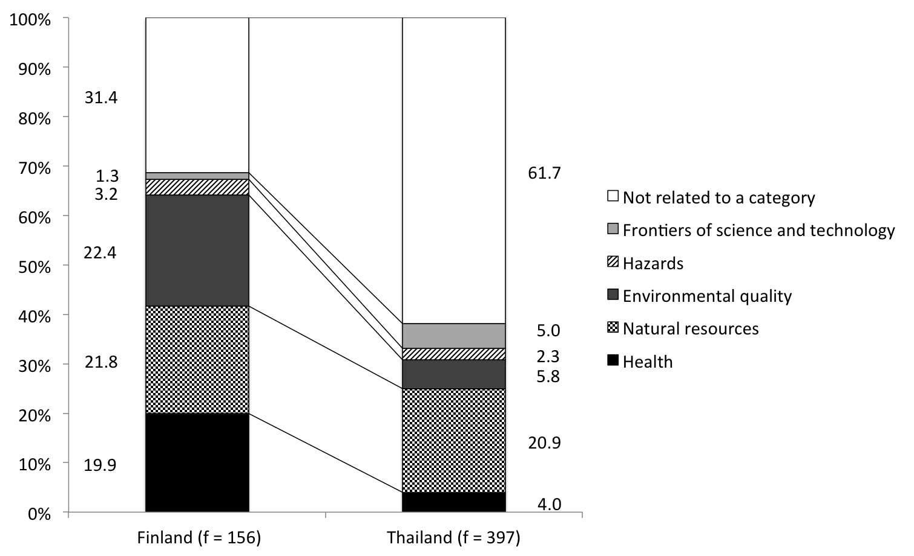
Figure 6. The comparative percentage of context use in Finnish and Thai science curricula

Discussions and Conclusion
In Finland, the science curriculum at the primary level introduces the science through three main subjects: environmental and natural studies (in grades 1-4), biology and geography (in grades 5-6), and physics and chemistry (in grades 5-6). However, the science in grades 1-6 in Thailand is taught through one science subject, ‘science’. The Finnish environmental and natural studies category is rather similar to the ‘science’ in Thailand. In general, based on our reading and content analysis, the Thai and Finnish curricula emphasize the same topics, such as scientific concepts and processes, scientific skills, use of scientific knowledge, nature, environments, technology, and science in the society.
There were ambitious topics in the Thai science curriculum that were not found from the Finnish curriculum. For example, the instructions to discuss effects on living organism from environmental change due to both nature and human beings; analyse and explain the changes resulting in transition of substances to new substances with different properties, and explain substance changes affecting living things and the environment. These are really challenging aims for grade 6 students. Moreover, the Thai curriculum emphasizes the ability to apply knowledge for useful purposes, pose new questions for subsequent exploration and verification several times through repetition. These qualities again reflect the fact that the Thai science curriculum absolutely took the competence aspect in the PISA science framework into consideration, while the Finnish curriculum showed all results under the four categories of analysis framework to be more balanced.

Main outcomes from the content analysis
The Finnish and Thai curricula could be analysed following the PISA science framework, although the aims in the curriculum have been described in different ways: Finnish aims are presented in the form of aims for teacher teaching and Thai aims as descriptions of learning outcomes.
There were about three times more texts in the Thai curriculum document than in the Finnish curriculum document. The relative emphasis of certain content area in the Finnish and Thai curricula was rather similar. However, the ‘living systems’ content was most emphasized in the Finnish science curriculum, while ‘physical systems’ was the largest content area in the Thai science curriculum. In Finland, the topic ‘nature of scientific explanations’ had a lower frequency than in Thailand. The topic ‘Nature of scientific inquiry’ in the Thai curriculum had the highest frequency among the sub-categories in both countries. The competence results showed that all three sub-categories of competences had equal frequency in the Thai curriculum. In Finland, the topic ‘Draw evidence-based conclusions’ had the lowest frequency and ‘Identify scientific issues’ had the highest. In general, the Finnish curriculum emphasised more contexts than the Thai curriculum. The context of environmental quality was used most in both science curricula.
The Thai curriculum has an increased emphasis on the scientific process rather than scientific concepts (c.f., Chandavimol, 1990). On the other hand, the Finnish science curriculum emphasises the concepts and contexts in which these concepts meet, rather than the process. According to Bransford, Brown, & Cocking (2000), experts’ abilities to think and solve problems is tied to a rich body of knowledge about the subject matter. With this knowledge, experts can notice features and meaningful patterns of information acquired from such sources as the Internet. Therefore, it is not straightforward to blame teaching of concepts instead of science process skills. An interesting question is: What is the optimal balance for teaching of concepts and processes?
The Thai science curriculum provided concepts and competences often without contexts, ‘not related to a category’, while the Finnish curriculum had about a 20% frequency for the topics of health, natural resources, and environmental quality. It is clear that context in the PISA 2006 Scientific Literacy Framework cannot cover all used contexts that satisfactorily align with the content knowledge (four systems). For example, ‘forces and motion’: forces acting on objects (Thai); motion of objects (Thai), and ‘energy’: various ways of producing electricity and heat (Finnish); properties and phenomena of light, and sound (Thai) were topics that were introduced mainly without context in both science curricula. However, emphasis on context is important form the point of view of learning. Bransford, Brown, & Cocking (2000) emphasise that the meaning of concepts becomes broader if a student meets the concept in different contexts. Moreover, the context has an influence to student interest (Cordova & Lepper, 1996; Bennett, Hogarth, & Lubben, 2003).

The number of lesson hours indicates the importance of science as a school subject
Science is one of the major subjects in most education systems throughout the world. The organization and time allocation for science teaching reflects the importance of science from the point of view of everyday and working life situations. In Finland, in grades 1–6 there are altogether 400 science lessons. Moreover, in Finland, the time allocation for science also includes the topics of geography and health education; and, therefore, less than 400 hours are allocated to the specific science subjects of biology, chemistry, and physics in Finland. In Thailand, the time allocation for primary school science education is 480 lessons. A comparison with other countries is rather difficult, because subjects are organized very differently across countries. For example, in Sweden, students are guaranteed 710 lessons (45 minutes per lesson) in science and technology from year 1 through year 6 (Lavonen, Lie, Macdonald, Oscarsson, Reistrup, & Sørensen, 2009). However, this number of hours includes both science and technology. Thus, in comparison, the number of science lesson hours is higher in Thailand than in Finland.

Curriculum and the PISA
The PISA 2009 results (OECD, 2010) demonstrate that the Finnish students are among the highest and Thai students among the lowest performing students in PISA. Several researchers and scholars have studied the PISA framework and the PISA outcomes (Anderson et al., 2007; Rodger, 2009; Neumann, Fischer, & Kauertz, 2010; Drechsel, Carstensen, & Prenzel, 2011). Although this paper focuses on primary science curricula, it belongs to PISA-related research.
Finnish and Thai primary science curricula have several aspects similar to PISA science framework. Therefore, it is understandable that Finnish students’ success in PISA has been earlier explained partly by similarities between the Finnish curriculum and PISA science framework (Lavonen & Laaksonen, 2009). However, the analysis presented in this paper revealed that the Thai curriculum is more similar to PISA science framework than the Finnish curriculum is. Therefore, the implementation of the intended curriculum, for example, by teachers and textbook authors (hidden, implicit or covert curriculum) could be more important for PISA success than a national level curriculum as such. Nor does the number of lesson hours in science explain the results as such: Thai students spend more time in learning science than the Finnish students do.
Possible reasons for the differences in PISA performance could be the availability of qualiﬁed science teachers, the student-teacher ratio, and the average class size. According to the PISA Thailand Project & IPST (2009), there were 30 per cent non-qualified science teachers in Thai schools. The OECD average of student-teacher ratio in primary class is about 11-16 students per teacher (OECD, 2011) while the Thai teacher has about 25 students (Atagi, 2011). In Thailand, the average primary class size is 50 students per class (Wößmann, 2003). In Finland, the average class size is fewer than 20 students per classroom (OECD, 2012). Consequently, the number of students in a classroom affects certainly how much time the teacher is able to focus on individual students and their specific needs rather than on the group as a whole. Furthermore, it can matter for student’s achievement as well (Ehrenberg et al, 2010).
A prominent issue that has to be taken into account is that the PISA assessment is for 15-year-old students, but this paper presents the comparative analysis of curriculum for students at a primary level. Referring to the science curricula analysis, the results showed that the contents of both Finnish and Thai science curricula at the primary level were in accordance with the PISA 2006 Scientific Literacy Framework, but the Thai curriculum fits it better. This better fit is a consequence of the active role of the Institute for the Promotion of Teaching Science and Technology (IPST), which has been responsible for science education in the Thai nation. IPST emphasises certain aspects for quality science teaching. They are an inquiry-based teaching/learning process, a higher-order thinking process, a scientific process, and the use of information Technology (IT) for teaching and learning (Boonklurb, 2000). The issues that have been emphasised are close to the PISA Scientific Literacy Framework.

Conclusions
The most interesting findings in our content analysis deal with the balance between concepts and processes. The Thai curriculum emphasizes PISA-related processes while the Finnish curriculum emphasizes concepts. Another interesting finding is related to contexts. The Finnish curriculum emphasizes contexts more than the Thai curriculum does. An appropriate context supports both learning and interest. However, the hidden or implicit curriculum or the way how qualified and unqualified teachers as well as textbook authors implement the curriculum has an influence on the learning outcomes. Consequently, both teachers and textbook authors should think about the balance between the learning of concepts and processes. Secondly, both should carefully think the contexts where they introduce concepts and processes. Moreover, the school context, like number of students in the classroom has an influence on outcomes.
Some ideas coming out from this paper could lead curriculum planners or science educators to design the science curriculum through the perspective of the PISA Scientific Literacy Framework in the future. For further research, we will determine the relation between the science curricula and science textbooks. Moreover, we will interview teachers in order to know more about the implementation of the curriculum.

Acknowledgements
The research presented in this paper was supported by the Thailand Commission on Higher Education.

References
Anderson, O.J., Lin, H-S, Teagust, D. F., Ross, S. P. & Yore, L. D. (2007). Using large-scale assessment datasets for research in science and mathematics education: Programme for International student assessment (PISA). International Journal of Science & Math Education, 5(4), 591-616.
Asunta, T. (1997). Primary science in Finland. Science Education International, 8 (1), 7–9.
Atagi, R. (2011). Secondary Teacher Policy Research in Asia: Secondary Teachers in Thailand. Bangkok: UNESCO. Retrieved from http://www.uis.unesco.org/Library/Documents/secondary-teacher-policy-research-asia-thailand-education-2011-en.pdf
Bennett, J., Hogarth, S., & Lubben, F. (2003). A systematic review of the effects of context-based and Science-Technology-Society (STS) approaches in the teaching of secondary science. Version 1.1 In: Research Evidence in Education Library. London: EPPI-Centre, Social Science Research Unit, Institute of Education.
Boonklurb, N. (2000). Current trends and main concerns as regards science curriculum development and implementation in selected States in Asia. In M. Poisson (Ed),. Science Education for Contemporary Society: Problems, Issues and Dilemmas. Final Report of the International Workshop on the Reform in the Teaching of Science and Technology at Primary and Secondary Level in Asia: Comparative References to Europe (Beijing, China, March 27-31, 2000) (pp.69-71). Geneva: International Bureau of Education.
Bransford, J.D., Brown, A.L. & Cocking, R.C. (eds.) 2000. How people learn: Brain, mind, experience, and school. Washington, D.C.: National Academy Press.
Chabalengula, V.M., &, Mumba, F. (2012). Inquiry-based science education: A scenario on Zambia’s high school science curriculum. Science Education International, 23(4), 307-327.
Chandavimol, M. Integrated science teaching in Thailand. Science Education International, 1(1), 9–10.
Cordova, D.I., & Lepper, M.R. (1996). Intrinsic motivation and the process of learning: Beneficial effects of contextualization, personalization, and choice. Journal of Educational Psychology, 88, 715-730.
Drechsel , B., Carstensen, C., & Prenzel, M. (2011). A study of the embedded interest items in the PISA 2006 science assessment. International Journal of Science Education, 33(1), 73-95.
Duggan, S., & Gott, R. (1995). The place of investigations in practical work in the UK national curriculum for science. International Journal of Science Education, 17(2), 137- 147.
Ehrenberg, G.R., Brewer, J.D., Gamoran, A., & Willms, J. D. (2001). Class size and student achievement. American Psychological Study, 2(1), 1-30.
FNBE (1994). Framework curriculum for the comprehensive school (in Finland). Helsinki: State Printing Press and National Board of Education.
FNBE (2004). National core curriculum for basic education 2004. Helsinki: National Board of Education.
Institute for the Promotion of Teaching Science and Technology (IPST). (2002). The manual of content of science learning. Bangkok: Curusaphaladphoa.
Kelly, A.V. (2009). The curriculum: Theory and practice. Los Angeles: Sage Publications.
Lavonen, J. (2008).Science literacy assessment. In PISA06 Finland: analyses, reflections, explanations, 67-109. Ministry of Education Publications 2008:44. Centre for educational assessment, University of Helsinki.
Lavonen, J., & Laaksonen, S. (2009). Context of teaching and learning school science in Finland: Reflections on PISA 2006 results. Journal of Research in Science Teaching, 46(8), 922-944.
Lavonen, J., Lie, S., Macdonald, A., Oscarsson, M., Reistrup, C., & Sørensen, H. (2009). Science education, the science curriculum and PISA 2006. In Matti, T. (Eds). Northern lights on PISA 2006: differences and similarities in the Nordic countries (pp. 31-57). Copenhagen: Scanprint as.
Ministry of Education. (2008). The Basic core curriculum education B.E. 2551 (A.D.2008). Bangkok: Kurusapa Ladprao Publishing.
Ministry of Education. (2008). Towards a learning society in Thailand: an introduction to education in Thailand. Retrieved July 3, 2012, from http://www.bic.moe.go.th/fileadmin/BIC_Document/book/intro-ed08.pdf
NCCBE. (2004). National Core Curriculum for Basic Education 2004.Helsinki: National Board of Education. Retrieved June 15 2012, from http://www.oph.fi/english/page.asp?path=447,27598,
37840,72101,72106
Neuendorf, K. (2002). The Content Analysis Guidebook, Thousand Oaks, CA: Sage Publications.
Neumann, K., Fischer, H. E. & Kauertz, A. (2010). From PISA to educational standards: the impact of large-scale assessments on science education in Germany. International Journal of Science and Mathematics Education, 8(3), 545-563.
OECD (2006). Assessing Scientific, Reading and Mathematical Literacy: A Framework for PISA 2006. Retrieved from http://www.oecd.org/
pisa/pisaproducts/pisa2006/37464175.pdf
OECD (2007). PISA 2006: Science Competencies for Tomorrow’s World, Volume 1: Analysis. Paris: OECD.
OECD (2010). PISA 2009 Results: Executive Summary. Retrieved from http://www.oecd.org/dataoecd/34/60/46619703.pdf
OECD (2011). Education at a Glance 2011: OECD Indicators, OECD Publishing. Retrieved from http://dx.doi.org/10.1787/eag-2011-en
OECD (2012). “How many students are in each classroom?”, in Education at a Glance 2012: Highlights, OECD Publishing. Retrieved from http://dx.doi.org/10.1787/eag_highlights-2012-25-en
Oliva, P. (1997). The curriculum: Theoretical dimensions. New York: Longman.
Rodger, W.B. (2009). Program for international student assessment (PISA) 2006 and scientific literacy: A Perspective for science education leaders. Science Educator,18(2), 1-13.
Stål, N. (2012). Teaching sciences in the Finnish compulsory school. Retrieved from University of Glasglow, School of Education Web site: http://artofteachingscience.org/countries/Edsystemfinland.pdf
Thailand PISA Project & The Institute for the Promotion of Teaching Science and Technology (IPST). (2009). School factors and learning quality [in Thai]. Bangkok: Seven printing groups publishing.
Valdmann, A., Holbrook, J., & Rannikmäe, M. (2012). Evaluating the teaching impact of a prior, context-based, professional development programme. Science Education International, 23(2), 166-185.
van den Akker, J. (2003). The Science Curriculum: Between Ideals and Outcomes. In B.J. Fraser & K.G. Tobin (Eds.), International Handbook of Science Education (Vol. 1, pp. 421–449). Dordrecht; Boston; London: Kluwer Academic Publishers.
Weber, R. (1990). Basic content analysis (2nd Ed.). Newbury Park, CA: Sage Publications.
Wößmann, L. (2003). Educational production in East Asia: The impact of family background and schooling policies on student performance (Working Paper Series Vol. 2003-17).
Yuenyong, C., & Narjaikaew, P. (2009). Scientific literacy and Thailand science education. International Journal of Environmental & Science Education, 4(3), 335-349.

Corresponding Author: pavineenui@gmail.com
University of Helsinki, Finland

